# Company Round Two: Verona, Murano, & A Cheese Tour

Right after the Crofts left to go back home to Idaho, my younger sister Melanie and her husband Mike arrived in Venice the very next day.

L to R: Scott, Me, Melanie, and Mike

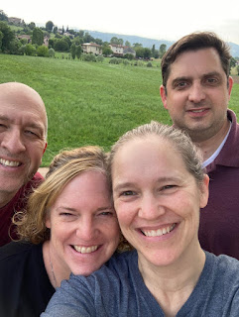

Video of their arrival and the moment they saw us in the airport: (10 seconds)

https://photos.app.goo.gl/V3vsEQSuiUnG1fw37

We all worked in the kitchen together to build our dinner, each person chopping or stirring something.

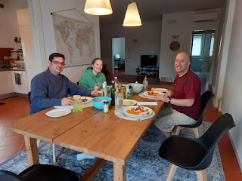

We sauteed some chicken cutlets wrapped up in prosciutto and then dredged in flour. We made a balsamic glaze of sorts in the pan, with some balsamic vinegar and chicken broth that cooked down and thickened up once we put the chicken cutlets back in. They were served with cherry tomatoes, fresh basil, and chunks of fresh mozzarella cheese. Cooked carrots were served on the side, along with a nice dipping bread to mop up whatever olive oil/vinegar/spice concoction you created on a little side plate.

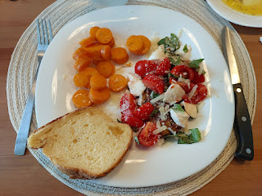

After dinner, we drove about 5 minutes north of our house to take Mike and Melanie to the same cute little gelateria that Anilyn found a few days earlier in Costabissara. We did a nice slow walk in the center of the tiny town while savoring every bite of gelato.  Melanie and Mike did an impressive job of staying awake until a reasonable hour to tuck themselves into bed for the night. :)

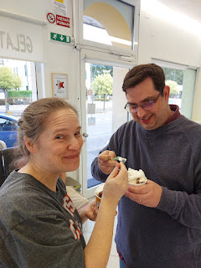

Our downstairs neighbor, Bruno, asked us if we wouldn't mind watering his lemon tree and several flowering plants around our shared property while he would be gone on a 10-day trip. Every evening we faithfully fulfilled this obligation, and Bruno just returned home safely on Tuesday evening.

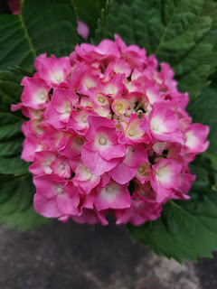

On Sunday (June 22), after Melanie and Mike slept for about 13 hours, we all went to church together. It was a 4-day weekend for all the military families (for Juneteenth), but Scott only gets the actual day of any federal holiday off, now that he works as a government contractor. We chose to stay close to home with our company, while several other families were off adventuring somewhere. This meant that our ward was very small again. I had been asked to teach the Relief Society lesson, but when Scott found out, he suggested that we should just combine our two classes since he would be teaching the same lesson in Elders Quorum (the men's class). So that's exactly what we did.

It was nice to free up that space in my brain for other things and just let him take the lead on the lesson prep. He did a great job as always. His new thing is to assign several classmembers with a quote from whatever general conference talk that is the basis for the lesson. He asks them to find the quote within the talk (using their smartphones), get some context for the quote, and then offer their insights on the quote. Everyone seem to really enjoy it, and they take it to heart. It gets more people involved than the usual 3 or 4 people, and it's so nice to hear from some other class members that usually stay quiet.

After church and a small afternoon rest period, we drove to Verona - about 45 minutes west. Our first stop was the Arena di Verona, a Colosseum that was built BEFORE the one in Rome and is more intact, too. Since Scott and I have seen the inside before, we opted to find a patch of shade and just wait for Mike and Melanie outside. It was quite toasty . . .

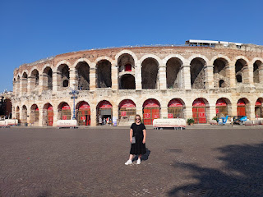

While sitting on a bench trying not to melt, I saw the cutest thing. A bride-to-be was with her bridal party and, though I didn't understand the reason for why she ended up doing this, I was intrigued. She jogged around the fountain in front of us 3x (in the scorching sun), while her bridesmaids splashed water on her (from their water bottles) as she jogged by. The crowd offered a half-hearted cheer and some light clapping when she finished. I think everyone was suffering a bit from the heat . . .

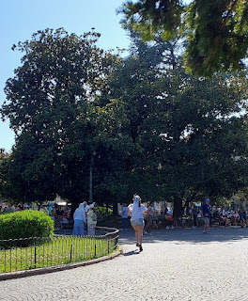

Video of the diligent bride running her laps: (5 seconds)

https://photos.app.goo.gl/pTJayfcASaNBMoVMA

Next, we walked about 20 minutes to get to the Giusti Gardens. We crossed the River Adige (pronounced AH-dee-jay), the second longest river in Italy.

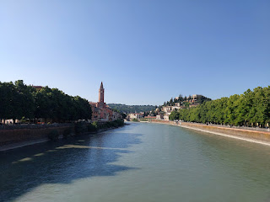

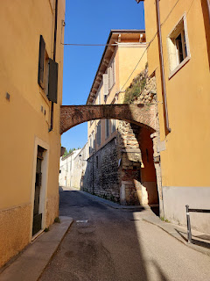

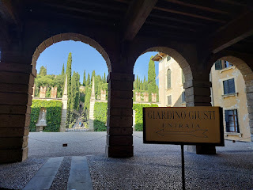

I had never heard of this place, but Melanie had found it in her advance research. It was so beautiful! I'm so glad she discovered it, because I think I will bring more people here in the future. As explained in the photo below, the garden was created at the end of the 16th century by Agostino Giusti, a collector, a music lover, and a friend to the Medici and Habsburg families.

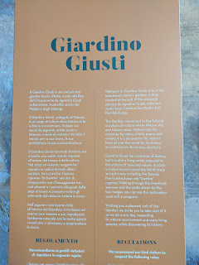

It is very walkable, but there are some steep steps that lead up to some additional precarious paths up above, with gnarly tree roots twisting this way and that on the trail. So be very careful!

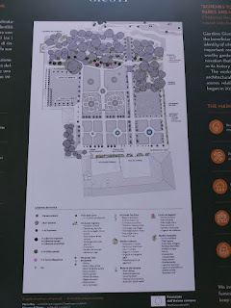

The lower paths are wide and consist of loose gravel . . .

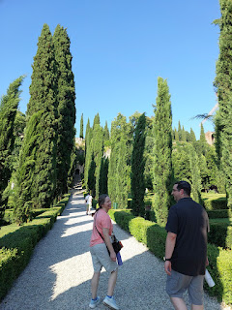

This sign describes some of the devastation that occurred in the area when a severe storm hit in August 2020. Several trees were toppled over, including a 500-year old tree named "Goethe". Students from Bologna University came in to assess and evaluate the special garden, and then they helped to clean up some of the mess.

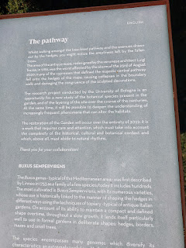

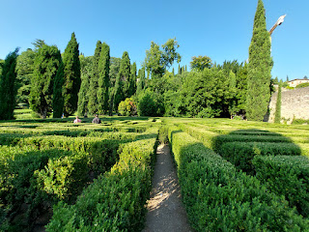

We eagerly entered the maze first thing . . . I was pleasantly surprised that the hedges weren't overwhelmingly tall and that we could see each other and the paths around us.

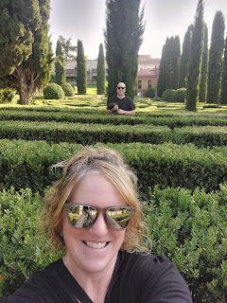

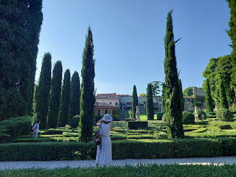

Statues and other forms of art are placed all throughout the Gardens . . .

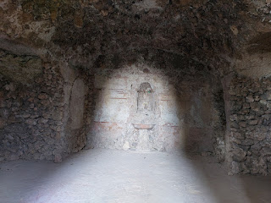

We walked up a long set of stairs to see what was up above . . . (3 seconds)

https://photos.app.goo.gl/4AYKGLuBC6D5heHu9

Even though it was very hot and humid, I'm so glad we made the trek! We had sweeping views of Verona from a great vantage point. (Can you tell how red-faced and sweaty I was, ha ha)

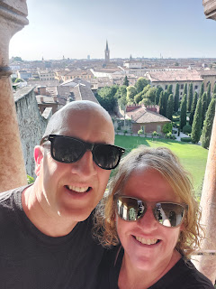

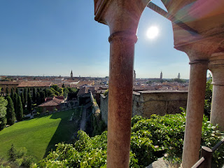

Video of the views from up on the hillside: (7 seconds)

https://photos.app.goo.gl/t5h6GEfo8rFidTDi9

I saw Mike and Melanie on the path below, so I called her phone so I could direct her gaze up to where we were. She took a photo of us - see if you can zoom in and find us . . .

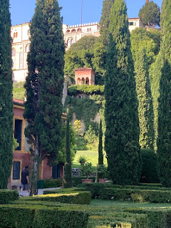

The trail zig-zagged through forested blooms and eventually led us back down to the main level . . .

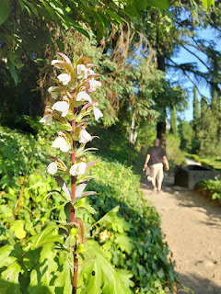

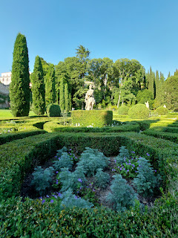

While I took a handful of photos, Scott found a shaded perch on which to plant himself for a few.

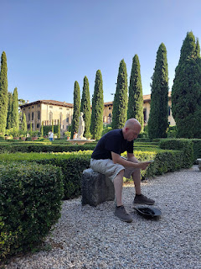

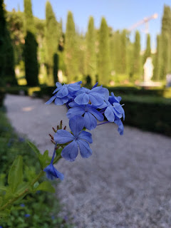

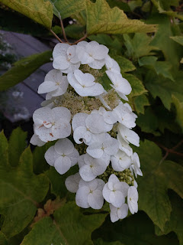

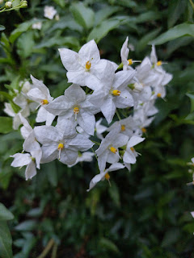

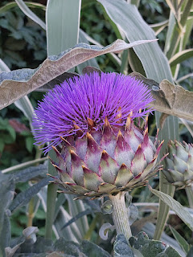

I enjoyed the gardens very much, in spite of the heat. However, in the future, I would prefer to go in spring or fall when the temperatures are more mild.

Our next stop was in Lazise, a cute little town on the shores of Lake Garda. Melanie told me afterwards that I should bring ALL our guests here because it was THAT cute. :)

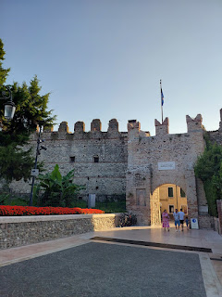

Video of some wisteria and something else that was very flowy and attached to the corner of a building in Lazise: (10 seconds)

https://photos.app.goo.gl/CJFnsvM5j9tp2zjDA

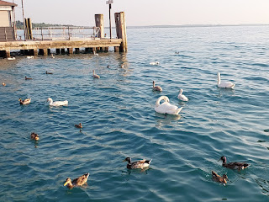

Video of swans and ducks a-swimming next to the promenade: (6 seconds)

https://photos.app.goo.gl/D99gjckgxU5U9A7U6

We found a restaurant next to the water for dinner. Melanie and I ended up ordering the same pizza - the Capricciosa. I split mine with Scott because I wasn't that hungry and I wanted to save a little room for gelato, ha ha.

I often order the Capricciosa throughout Italy because it has more vegetables on it than most varieties. While it's a bit lighter and is completely different from my favorite supreme pizza at the Round Table in Ukiah, CA, I am always looking for something that attempts to rival my childhood favorite. The Capricciosa has ham, olives, mushrooms, and artichokes on it.

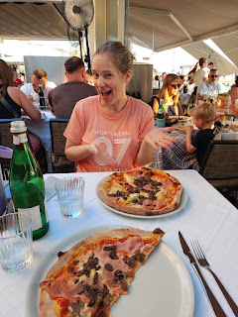

We lucked out and saw a beautiful setting sun over the lake to finish out the day . . .

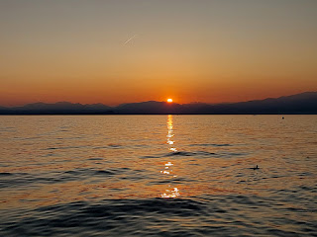

Sometimes when you choose a cup size for gelato, they will fill it to just barely over the rim - but sometimes they are overly abundant as they load the cup with towering heaps on top. You never really know until you watch them pack the cup in front of you. This time, I mistakenly assumed that they wouldn't be aiming for Mt. Everest on top, so I asked for a larger cup size. I was wrong. They packed it and then built Mt. Everest on top, too. It was way too much for me, and Scott was full of pizza, so I ended up having to toss some of it, unfortunately. But it was oh so yummy.

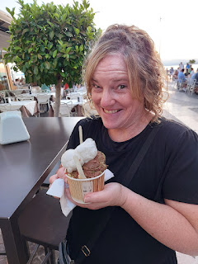

The following day, (Monday, June 23rd), while Scott was at work, I drove Mike and Melanie to the NaturaSi in Dueville for lunch. This was something that Melanie was very much looking forward to, and rightly so! The food here is always so fresh and healthy, with more options than you could ever possibly sample. Once you fill up your cafeteria-style tray, your plates with all the colorful foods get weighed at the register and you pay based on that.

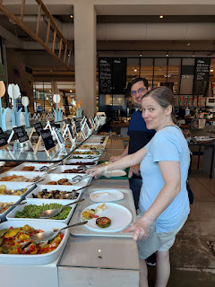

I am always a sucker for pasticcio (pass-TEE-chee-oh), or messy lasagna. This time, I saw something new and I was excited to try it. I got a large portion of what appeared to be a cheesy cauliflower casserole. It did not disappoint. It tasted similar to my mom's yummy macaroni and cheese casserole, but with cauliflower instead of pasta.

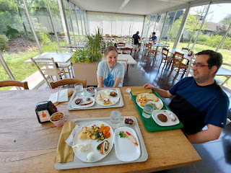

Our next stop was in Bassano del Grappa so that Melanie could see a couple of places that are connected to our Bassano ancestors, including their old family home.

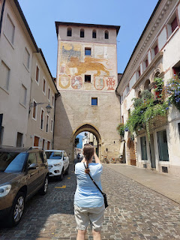

The location of the old home is next to Porta Dieda, an historic entry point into the city. Passing through the arched "doorway", we turned left and then the house is on the next street over. While we don't have 100% proof that this was the Bassano home, there is a lot of circumstantial evidence that it was. Plus I get

feelings

when I stand there, both in front of the house and also inside the long hallway that leads to the inner courtyard. So that's all the proof I need. :)

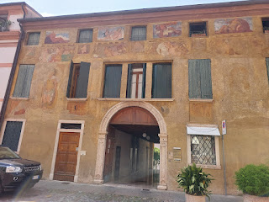

At one point, Melanie came over to hug me because she was feeling all the feelings, too. XOXO

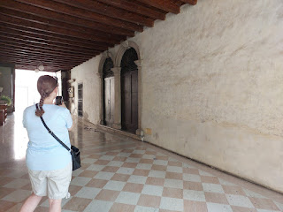

This little bronze crest was on the building next door to the Bassano house . . .

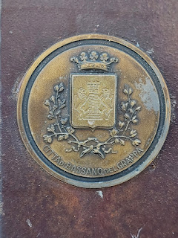

Next, we walked over to the Museo Civico, or Civic Museum of Bassano del Grappa. There are some beautiful paintings upstairs that were made by Jacopo dal Ponte, also known as Jacopo Bassano. I still don't know exactly how he is related to MY Bassanos, but I do know that some family members were painters and artisans, while others were musicians and instrument makers. The family was sure blessed with some beautiful talents and gifts.

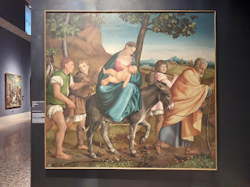

This painting by Jacopo dal Ponte is entitled, "The Virgin Enthroned with Child between Saints Bassianus and Francis", and was created in approximately 1542.

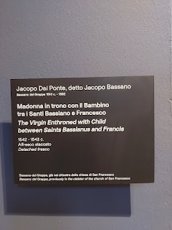

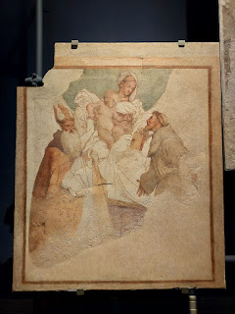

There is an important clue in the next photo regarding the origin of the Dal Ponte Family that I had not noticed before until now . . .

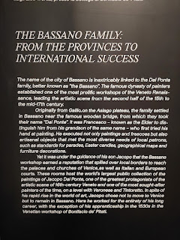

I think I've taken a photo of this same sign before on a separate visit to the museum in Bassano, but I just hadn't picked up on the clue before. It says that the Dal Ponte family came from the Asiago area before settling in Bassano del Grappa. I looked on a map to see where Gallio is in relation to Asiago, and they are neighboring communities.

This was confusing to me because it doesn't jive with the background locations of the Bassano family, from which we descend. I turned to AI for a quick answer and basically it confirmed my new worry that the two families are likely not related at all. The Dal Pontes became known as "Bassano" simply because they lived there, not because they are related to the Bassanos. There is no known link, per two separate and very reliable sources.

This puts my years-long quest to find a link between the two families to rest, sadly. I'm sure they knew each other, though. They lived in Bassano del Grappa during overlapping years, and they both dabbled in artistic ventures: music and art. Surely they would have known each other and moved around in some of the same circles.

I'm not sad about the news, but I am disappointed a little bit. I've been so excited each time I've seen a painting by Jacopo dal Ponte because I was sure he was a distant cousin of mine. But really, what it all boils down to is that we are ALL cousins of varying degrees, ha ha. We are all part of God's Great Big Eternal Family, so really, we

are

related - all of us. :)

And Jacopo dal Ponte does have some magnificent paintings, so there's nothing really to be sad about. He was talented and he shared his talent with the world. We should all be grateful for him and for all the gifts of art that he contributed in his lifetime.

But I will hereby end my quest to find a specific link between the Dal Ponte and Bassano families.

That being said, our next stop was actually ASIAGO . . . we had a very interesting cheesemaking tour to take part in at the Caseficio Pennar. (Caseficio is pronounced like: Koz-eh-FEECH-ee-o)

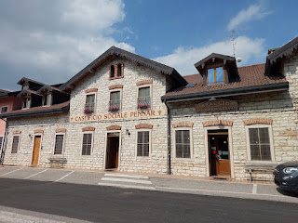

Our tour guide was named Liesa and she was lovely. She spoke really good English to be able to explain the process of cheesemaking to us.

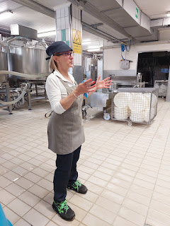

We even got to wear some very stylish hairnet-style booties over our shoes during the tour!

For a video tour of Caseficio Pennar, Liesa told us that she made a YouTube video a couple years ago and I just found it. Yay!

(3 minutes)

https://www.youtube.com/watch?v=2Fqo4j-TWSc

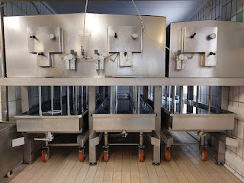

The cows graze high up in the mountains during the summer months, eating only local grasses and flowers. In the winter months, they stay indoors because of the cold (and snow) and they only eat locally produced hay. In the summer, their milk production has an off-white or cream color to it. But in the winter, their milk is very white. Because of the seasonal changes in their diet and the subsequent color of their milk, it also changes the flavor and color of the cheese, too.

This is a mold for making mozzarella cheese balls . . .

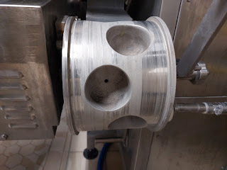

These are the molds that shape and retain the fresh ricotta each day . . .

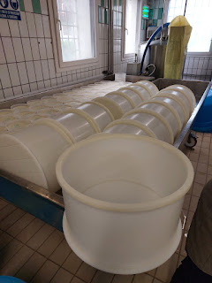

Each wheel of cheese is stamped with a QR code and identifying information that is specific to Caseficio Pennar. It identifies its origin, the date of creation, the batch number, etc.

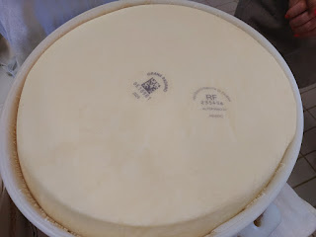

A large batch of curds . . . (the whey is sent off to the pig farmers for their pigs who happily slurp it up)

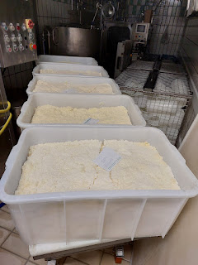

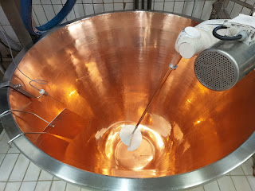

Copper vats are where the milk gets churned into cheese daily . . .

Video of the giant copper vats that hold the milk: (6 seconds)

https://photos.app.goo.gl/MZwep3XmNyiCG8gKA

Only one person is in charge of the cheese stirring per shift. This is the tool that is used.

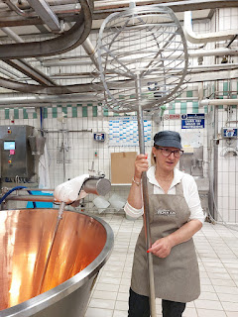

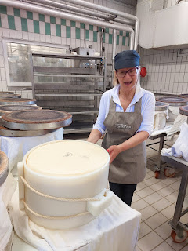

Liesa let us touch one of the uncovered cheese wheels . . . it was still very warm.

Video here: (7 seconds)

https://photos.app.goo.gl/Xr6PZpYZFhkUazuP7

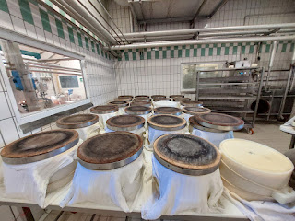

Melanie, effectively showing the difference in height between her and the ginormous vat that holds something like 25,000 liters of milk (I think). Maybe it was more like 50,000 . . .

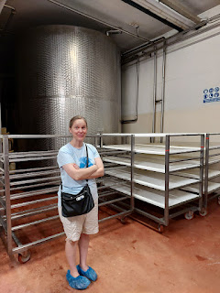

Video of where the milk sits overnight: (10 seconds) Maybe this is where she told us there are 50,000 liters in each of these giant tubs . . . I can't remember all the details now . . .

https://photos.app.goo.gl/hVeW8CiXgqxoRJf68

Each wheel is pressed with identifiers around the edge, too. Not only does it say Asiago repeatedly around the circumference, but there is a batch number, and their unique symbol for Caseficio Pennar.

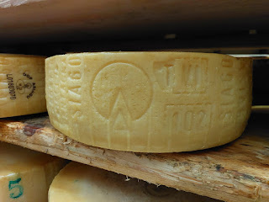

So. Much. Cheese. It was unbelievable how many wheels of cheese they have in the cold storage room! And each one weighs roughly 45 pounds. Wow.

Video of just a couple of the rows from floor to ceiling: (7 seconds)

https://photos.app.goo.gl/i5JPS1WgSNy8e4gG8

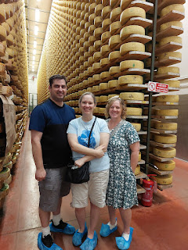

At the end of the tour, we got to hold one of the hefty cheese wheels . . .

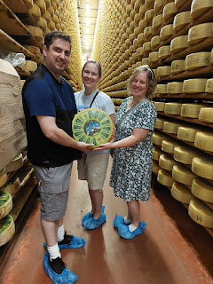

And then we got to sample 4 types of cheeses that they sell in their shop. I tend to enjoy a more mild cheese, so I bought some of the Asiago Mezzano (front right in the photo below). I've bought some of the mildest Asiago from them before (front left) and it was yummy. I decided to branch out and get the "next step up", purely because I was thinking of making a roux sauce for either some pasta, or veggies, or both, and I thought it would add a nice flavor.

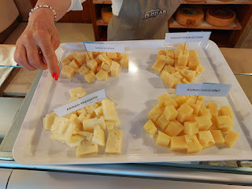

A giant cowbell hangs from the beams above the storefront counter area . . .

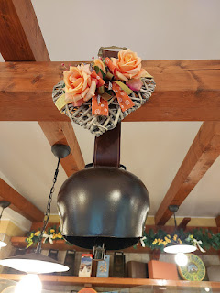

What a great day! It was an epic drive up and down the mountain to get to and from Asiago . . . We drove up a different way than how we got home later, since we went up from Bassano originally. There were less hairpin turns going up the first way than the 17 that we did on the way home, ha ha. The fun thing about seeing the signs that say Tornante 17, Tornante 16, etc. is that you know exactly how many there are by the time you reach the bottom. Going up . . . you just have to wait and wonder.

I remember wanting to go to bed earlier that night because I was so tired. I think it was starting to hit me from all the many days in a row of driving, seeing, playing, hosting, etc. PLUS the heat. But I did really enjoy sharing Bassano with my sister and also sharing my very first cheese tour with her, too.

Video of Melanie taking a walk behind our house with a gorgeous sunset: (5 seconds)

https://photos.app.goo.gl/p39BBDAWD7u63ZT99

Mike and I were on the balcony chatting when we saw her walking by. Hey - fancy meeting you here!!

On the last full day with Mike and Melanie, we rode the train out to Venice and then island hopped over to Murano. We tried to get there as early in the morning as possible, but it was already 9:00 a.m. and hot by the time we walked out of the Santa Lucia train station to behold the Grand Canal.

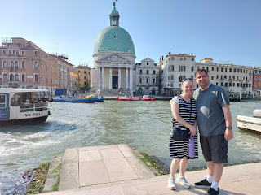

Per my suggestion, we walked a few minutes north so that they could see the Jewish Quarter of Venice, which was right on the way to catching a ferry to Murano.

We passed by a small open fish market with all sorts of fish for sale, big and small. From a large swordfish head all the way down to a bucket full of tiny snails.

Video as we crossed one of the canal bridges near the Jewish Quarter: (9 seconds)

https://photos.app.goo.gl/ikJz6HwcNPPTcwry9

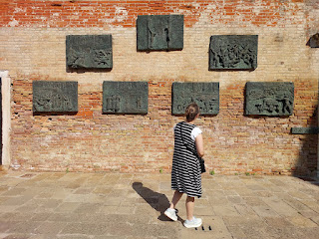

We had a special and very touching moment in the corner of the Ghetto as I pointed out the "tripping stones" to Melanie, which included the name of Edoardo Bassani, a relation to our Bassanos. The tripping stones were made by a German artist who wanted to memorialize the individuals who were torn from their homes all over Europe and then sent off to Auschwitz or another similar horror that precluded their murders.

There was a lot of construction going on in the Jewish Quarter, including the Ghetto, which meant a lot of dust had settled on top of the tripping stones, which are normally an elegant bronze and very visible. I used my shoe to try to brush some of the dirt off so she could read it better, but it didn't really do much.

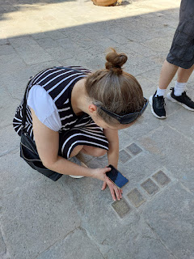

Then, to our surprise, this man came out through the door of the building in front of us, said something in Italian and started pouring some water from his water bottle on top of the tripping stones. He also had a little tissue or napkin in his hand to clean the stones even more. That was one of the kindest things I've ever seen in Italy, and I've seen a lot of wonderful things. I'm pretty sure he was a construction worker because of how he was dressed, plus his paint-splattered shoes were a pretty big clue . . .

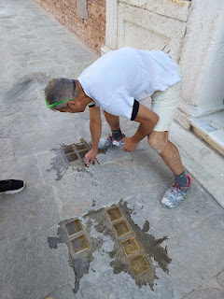

He took the time to notice us from inside the building where he was, and then discerned that we probably wanted to read the names on the stones, because they mattered to us. He must have seen us trying to take some photos and decided that we needed something better. What an incredible gesture of kindness!

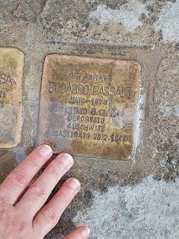

After we spent a few minutes in the Ghetto, where I pointed out a few details that I had learned from recent tours, we made our way over to the St Alvise ferry dock. If you picture Venice (Lagoon Venice - different from mainland Venice) as a giant fish (because it IS shaped like a giant fish), we were at the crown of its head to catch the water bus.

We accidentally took the water bus that heads in the opposite direction, but it was breezy and felt refreshing to be on a moving boat. We noticed our mistake after about 3-4 stops, so we got off and waited for the right one heading in the other direction. We passed by the Ospedale of Venice (Hospital) and I saw their ER for the first time. There are little ambulance boats and an ER boat dock that you can see in the photo below.

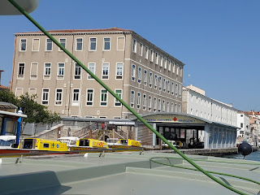

It only took a few minutes to get over to Murano from the northern section of Venice . . .

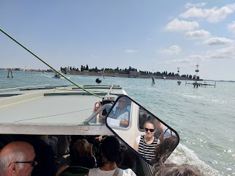

I snuck a very fancy video of Melanie in the side mirror of the water bus while we bounced along toward the Cimitero of San Michele stop: (10 seconds)

https://photos.app.goo.gl/w6UN55rtAGgTnYoV9

We didn't get off at the cemetery stop, but I would love to go for a walk in there sometime when it's not 90-100 degrees. It's an island of its own, built somewhat like a fortress, but it's a fully enclosed cemetery that was established in 1807.

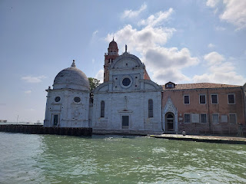

We got off at the Murano Colonna stop, which was next after the cemetery. After applying a good layer of sunscreen in the shade, we stepped out into the hot sun and started a slow little meander down the first alleyway street of Murano.

Very quickly, we noted that there are shops after shops after shops with items for sale that were made from glass. Murano is world-renowned for its glassmaking techniques, the art of which has been passed down for many generations. In one of the shops we stepped inside (5% curiosity + 95% need for A/C), a man approached us and offered to take us back to watch a glassmaking demonstration. Yes, of course! Si!!

Glassmaking used to primarily be in Venice, but after too many fires and the hazards it created, all production was moved out to the island of Murano in 1291.

Here is a link to a great article about the history of glass in Murano - it's a short and very easy read.

https://nativetrailshome.com/history-of-murano-glass/?cn-reloaded=1

If we thought it was toasty outside, then we were clearly weak and pathetic. These guys that work in the hot furnace area for hours on end are the real heroes.

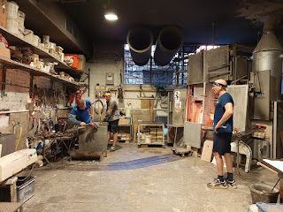

Video of the artist adding feet to the bull that he's making: (15 seconds)

https://photos.app.goo.gl/uL8pZskKeEvLAxAF8

Video of the artist using a blowtorch to heat the bull's feet: (8 seconds)

https://photos.app.goo.gl/rFAk5V6szymuir1fA

The blowtorch allows for direct and controlled heating of the glass, whereas the furnace heats the entire piece.

Video of the artist clipping the feet before it goes back into the fiery furnace: (7 seconds)

https://photos.app.goo.gl/CQZEuUZuJMcnWjsq7

For this artist to be doing what he was doing right there, he had to have a solid 25 years of experience first. Young boys usually begin their training around the age of 12, but they are considered a Master when they have completed 25 years of work experience.

After our demonstration was finished, the same man led us upstairs to the "Fancy Studio", as I like to call it. Just as I was taking a video of all the elaborate and exquisite pieces, he told me that I couldn't take any photos or videos up there. They really want to protect their unique pieces of art from copy-catters, I guess. Little did he know, he didn't need to worry about me. I won't be working near a blistering hot furnace any time soon.

Well, here's the few seconds of video that I got before I was scolded: (10 seconds)

https://photos.app.goo.gl/hVepoMwpwGiaxvGJA

The pieces of art in that upper room were SO PRICY. I asked him about one piece - and it was like 3900 euros. A few minutes later, I asked him how much for a beautifully crafted glass chessboard and figurine set that was sitting on a little table . . . and he told me 2300 euros. Cough cough . . . No thanks. He knew that I lived nearby and could potentially carry them home instead of having them shipped, so he offered me 2,000 euros as a bargain. Thank you, but no thank you.

We made our way downstairs to where things are significantly cheaper, and that's where I found a pretty little bedside clock to take home with me. I had seen these in other places around Venice before, but I thought it would be nice to purchase one from its original source. It was roughly $30. Much more manageable. :)

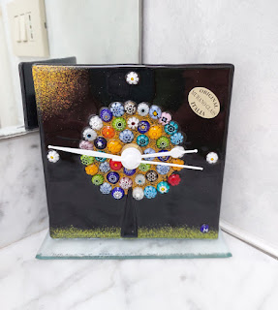

Melanie had mentioned that she also wanted to see the Basilica dei Santa Maria e Donato, so we made our way over, which took about 15 minutes on foot. I was so hot and sweaty, it was hard to take the time to absorb anything beautiful as we shuffled along in the heat. But Murano really is a beautiful place.

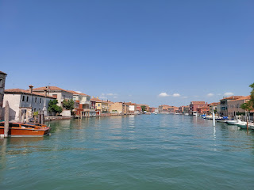

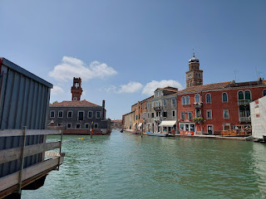

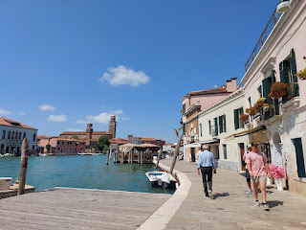

Approaching the Basilica . . .

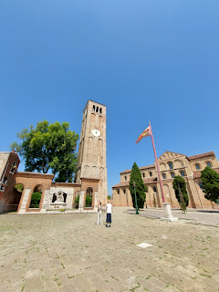

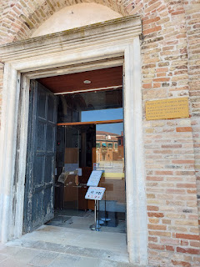

The Basilica and its Byzantine mosaic flooring were built in the 12th century, between roughly 1125 and 1141 A.D.

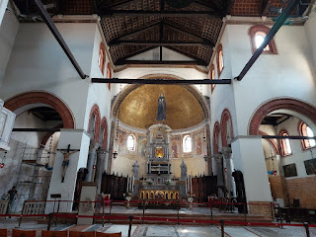

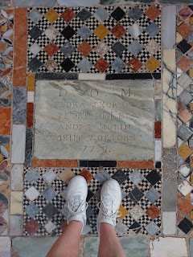

The flooring was especially beautiful, and it reminded me of the Doge Palace and Basilica at St. Mark's Square in Venice, which was built around the same time period.

Here is an article explaining the history of the church, with plenty of photos:

https://www.savevenice.org/project/mosaic-floor-of-the-church-of-santa-maria-and-san-donato

After we had just seen a glassmaking demonstration with all the attention to every minute detail, seeing this glass version of Jesus on the Cross was awe-inspiring. I don't know how they were able to make every curve, every feature of his face, his feet . . . look this good.

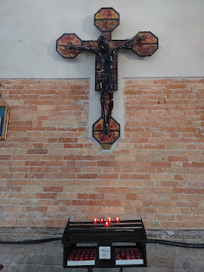

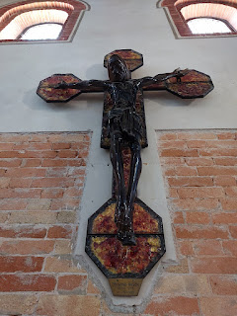

The gold tile mosaic of Mary above the altar reminded me both of the Basilica in Venice and also of the churches down in Ravenna, Italy - a place that's considered to be the mosaic capital of the world. Gold tile mosaics are present in both places. I wonder if it was a style choice from the period in which it was created, or if it was more of a signature style from a particular artist . . .

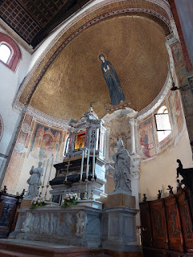

Stained glass windows portrayed each of the original 12 disciples of Christ . . . (I only took this one photo because it was sitting at a weird angle and I couldn't access the other ones very well.)

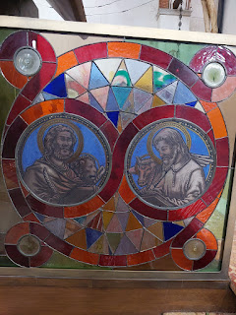

This old pipe organ was built by Gian Giacomo Antegnati in 1536, making it roughly 489 years old by now.

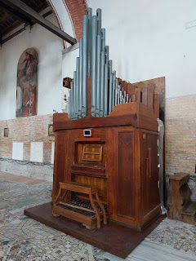

These next 3 photos are extremely interesting and they explain the background to the Basilica and also the symbolism found within the mosaic tile flooring and other areas, too. (click photos to enlarge)

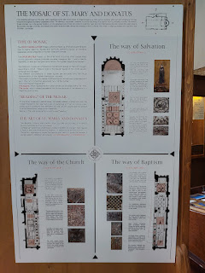

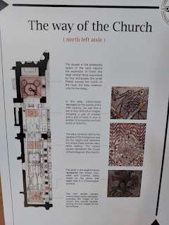

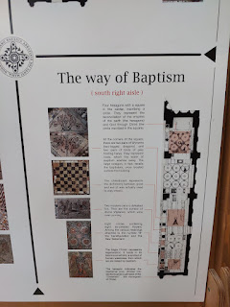

From the top, going clockwise: Melanie's feet, Mike's feet, and mine at the bottom. We had to hunt for this special tile square that was made to look like a chessboard. In the third photo above, as it describes some of the symbolism that relates to baptism, it says: "The chessboard represents the dichotomy between good and evil (it was actually used to play chess)."

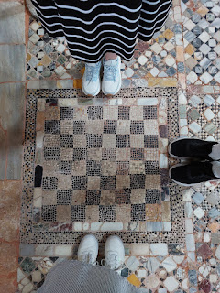

All in all, it was a very interesting Basilica with rich symbolism everywhere. I enjoyed spending some time there before stepping back out into the heat again.

We made our way to a place that had been recommended to us as a restaurant that serves the traditional moeche crab that is unique to Murano. I was super interested in trying some! But as it turned out, the moeche crab wasn't in season right then . . . darn it. But we were the first lunch customers of the day and the restaurant was so quiet, and AIR-CONDITIONED. We had been seated all the way in the back where it was a little darker and more peaceful away from the busyness of life outside the main door at the front, so we decided to stay and just order something off the menu anyway because we were already so comfortable and ready to rest for a while.

I found something called spidercrab salad on the appetizer section of the menu and I was 100% down to try it. The crab was very delicate and sweet, and it contrasted well with the avocado and lime-spritzed chopped salad. I enjoyed every single bite.

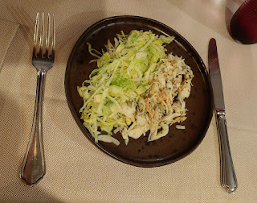

For my main dish, I ordered the cheese stuffed ravioli on a bed of pureed peas. It was freaking amazing. I didn't want to eat it too quickly, because there weren't very many bites to be had . . . this was a fancy restaurant and I paid way more than I would ever spend for a lunch. But it was absolutely delicious. I would have to say it was worth every penny. And no, I'm not going to tell you how much I spent, ha ha.

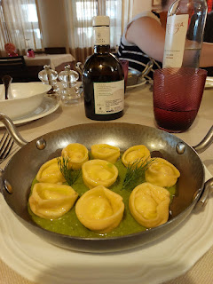

While we were eating, my eyes kept darting over to this old map of Murano that was on the wall nearby. I made sure to grab a photo before we left. I wish I knew the date it was created, but I couldn't see any year written on it.

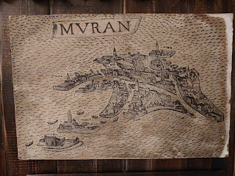

After a restful hour in the restaurant and with happy tummies, we set off to make our way back home to Vicenza.

Murano can be summed up in one word: shopping. While Venice offers museums, schools, studios, gardens, restaurants, and many more categories of exploration, Murano was mostly just glass shops and/or studios to make their world-famous glass. Yes, I'm sure there are few other things mixed in, like restaurants, and a museum, but for the most part, it's just glass shop after glass shop for dayyyyys . . .

These little glass piggies were super cute though . . .

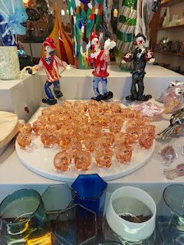

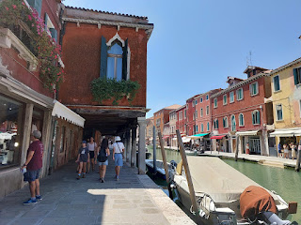

On the ferry back to Venice . . .

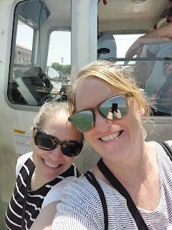

Video passing under a canal bridge: (13 seconds)

https://photos.app.goo.gl/77UsFiaJ1UvC6aMu6

Video of some of the construction happening in Venice: (7 seconds)

https://photos.app.goo.gl/Ubitv953CTHw73mK7

Come ride the water bus with me! I took a longer video as we cruised back toward the train station:

(1 min, 18 seconds)

https://photos.app.goo.gl/cx9REbuLP56yxdwr9

On the train back to Vicenza . . .

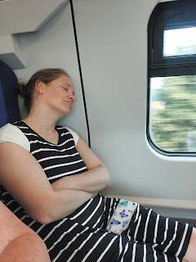

While Melanie took a little rest, I made us a little charcuterie platter to tide us over until dinner.

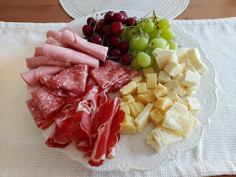

The next morning, I drove Melanie and Mike to the Venice Airport at 7:30 a.m. so they could catch a flight to Prague. Mike served as a missionary in Prague many years ago (roughly 1994-1996 I think) and was eager to reconnect with a place that has held a special place in his heart.

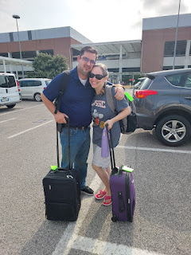

They had a lovely time there in Prague, soaking up the culture, the food, the sights, and even paying a visit to the Mission Home where Mike used to work so many years ago. They made it home in one piece and now they're adjusting little by little to the different time zone . . .

I'm so glad they could come and play with me in Italy! I especially loved that we found some new places to explore together. Sometimes I end up going to the same places on repeat, and while I don't mind this for a few of those places (like Chioggia), I don't want to get tired of the rest.

Melanie left us this "review" and I thought it was cute enough to frame so that all of our future guests will think we're awesome!!

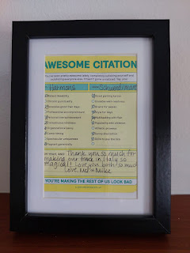

On the day that they flew off to Prague, we had an especially hot day in Vicenza . . .

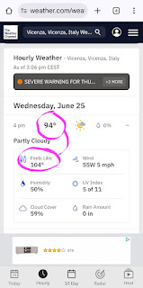

I've experienced 4 years of June in Italy as of this writing (2022, 2023, 2024, and 2025), and I've never seen it this hot before. I would say, "Good thing I'm headed back to Idaho for a month, where at least it cools off at night", but I don't have any air conditioning over there. I can hide comfortably in my house

here

for as many hours of the day as I want to, and I always have the A/C running nonstop. What a blessing!

In other news . . .

I finally got in to see the eye doctor!! Yay!! We had to drive to Verona for the opthalmologist that was recommended, but it turned out to be just 35 minutes of driving each way. The young doctor was very nice and also very efficient. We were out of there in maybe 30 minutes, and now I have a prescription for a new set of glasses.

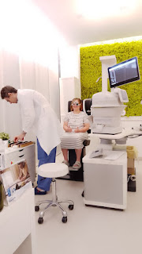

I just found a place this week in the Palladio Mall where I chose a pair of glasses that are so cute and comfortable. They will be ready for pickup in about 2 weeks.

I also recently went to see the endocrinologist, per the recommendation of my primary care doctor here in Vicenza. He didn't have anything super exciting or eye-opening to tell me, so that's good. It's just all part of the Italian medical process. You gotta see everyone and check all the boxes because that's what they do.

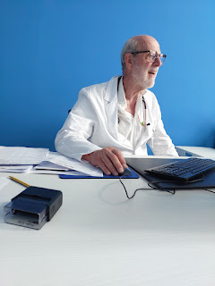

We've had some beautiful sunsets still happening on most nights . . . And we especially loved how there was some neon pink lighting that peeked out from behind the Dolomites in the distance one evening . . .

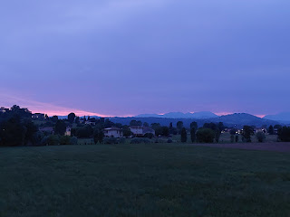

Video of the pink sunset: (17 seconds)

https://photos.app.goo.gl/suQUN7EEf1N72EH1A

On another evening, orange was the primary color of the setting sun . . .

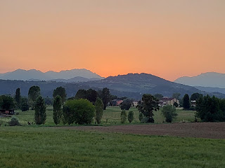

Grandchildren updates . . .

Jack and Maisie are enjoying life in their new house in St. Paul. I had a video chat with Jake one day, and he let me watch Jack play and explore in the yard while we visited. We were coming back from a day out with the Crofts when this call took place, so that's why I'm wearing a seatbelt down in the bottom corner. Scott was driving, so I mostly fielded the call. :)

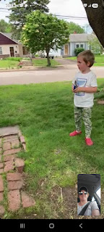

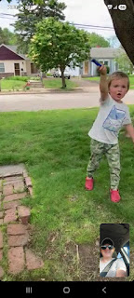

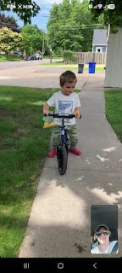

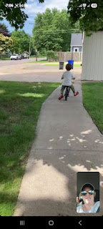

Jack loves his glider bike (with no pedals at the moment). He's learning the art of balancing on it for now. He also loves to use his dad's tools to explore stuff in the yard - a screwdriver to dig in the tree trunk, a wrench to fix stuff, etc.

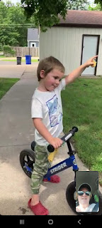

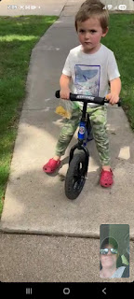

Mr. Rosy Cheeks . . .

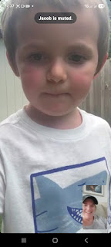

Meanwhile, Miss Maisie is getting so big . . .

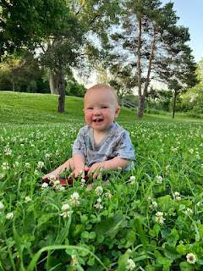

She was hungry, but didn't realize that her snacks were stuck to her "bum", ha ha ha

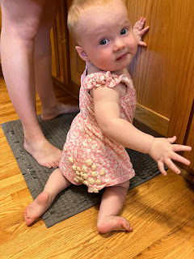

She loves to hang out in the living room window with Jack and watch the world outside . . .

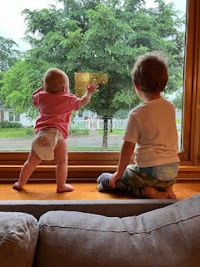

Jack was quoted as saying here, "When I grow up, I will study data science and then I will work from home." He knows at just 4 years old that his daddy has a sweet job that allows him to work from home.

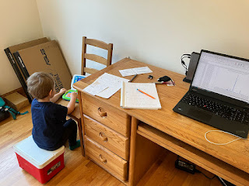

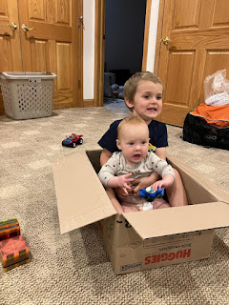

Hannah, Maisie, Jake, and silly Jack . . .

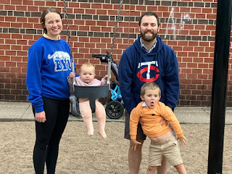

They recently traveled a couple of hours away to see the Blue Angels perform again . . . they had a great time and the kids wore protective headphones over their ears.

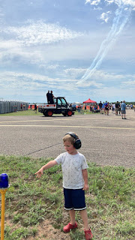

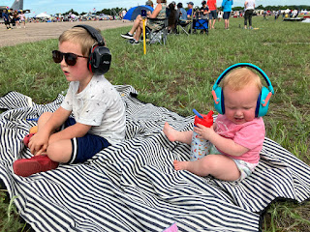

Gwen - sleeping like a little angel in the same blankie that her mother used to curl up in for many years.

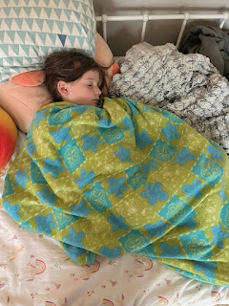

Amber and her family had a special 24-hour visit from Grandpa John this past week! He made it a point to stop and see them on his way up to Northern Idaho to visit his youngest son (and my baby brother) Michael. Amber told me that they had the best time with him there!

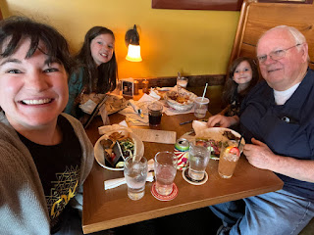

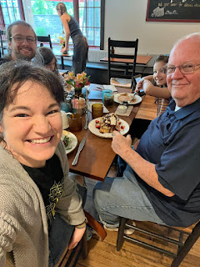

Amber shared the following in our family group chat: "I was chatting with [Grandpa John] at 9:30 after I put the girls to bed, when suddenly a paper airplane flew into the living room. It was a note that said, 'Grandpa John, you are nice and funny and I love your stories. Thank you for coming to visit us. Love, Abby.' " What a sweet thing for her to say!! XOXO

I got some details from my Dad on his visit to Michael's house up near Coeur d'Alene. Apparently it was time to harvest 22 chickens, and they had quite the setup including a scalding station to loosen the feathers, a plucking machine, and everything else to make the whole thing a success. Wow. What homesteaders they are!! And they have at least one herd of bees, with a honey-making operation that is very successful, too.

And lastly . . .

Waaaay back on June 13th - on our anniversary, I was able to attend a very special luncheon to honor my wonderful husband. Even though he's been retired now for a couple of months (from the military), his co-workers wanted to celebrate all of the contributions that he's made in the past 3 years. We met at a restaurant near Monte Berico, high on a hill that overlooks Vicenza.

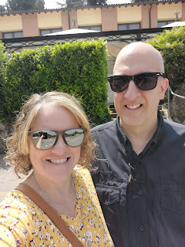

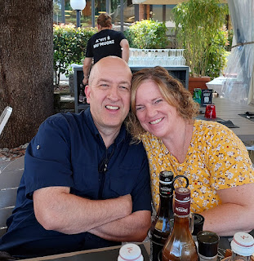

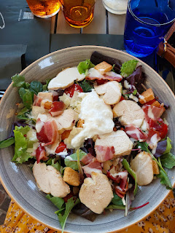

For lunch, I ordered a Caesar salad that was super delicious, and Scott ordered the beef tartare, which he said was equally delicious.

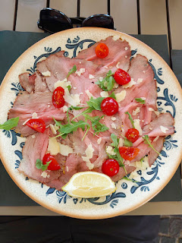

Lt. Colonel "O", Scott's former boss, stood up at the end of the meal to tell everyone why he loves Kenneth Scott Harmon so much. He expressed his gratitude that Scott takes his job so seriously, and the thought that he puts into everything that he does. He said that without Scott, many operations likely would have failed entirely. But with Scott at his computer, doing what he does best, they had success after success after success.

He even turned to me and shared his appreciation for the support that I have given to Scott and how that allowed Scott to fulfill his responsibilities even better. He said something like, "Usually when someone is getting close to retirement, they can smell the finish line and they lose focus. And sometimes their spouse at home is even more eager for their soldier to be done. If the spouse is feeling antsy and impatient, this carries over into the workplace and into the delicate work that we need to be focused on. But with you and Scott, we could tell that he had 100% support from you at home, which allowed him to keep his head in the game right up until the very end."

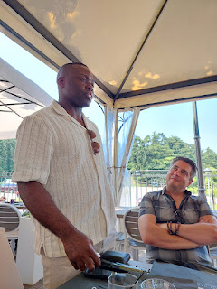

He also added his admiration for our long-lasting marriage and the beautiful friendship that Scott and I have, saying that in this day and age it carries a great deal of weight in helping to make the world a happier place to be. I was surprised and caught off guard from all of the words of praise that he directed toward me and toward us, but I was also very grateful that he took the time to share all of his thoughts with everyone present at the luncheon.

Scott was presented with this large token of their appreciation: (which says)

CW4 Kenneth Harmon

Ken, your commitment to excellence and professionalism at SETAF-AF have been invaluable and benefited all of us. Your contributions played a significant role in driving operational success for both our organization and the fires community. We have all been influenced by your genuine friendship and positive impact.

Thank you, Ken, and wish you all the best in your future endeavors.

[And then they added their favorite quote that Scott always says at work]

"Good morning Gents, what's going on?" ~ Ken

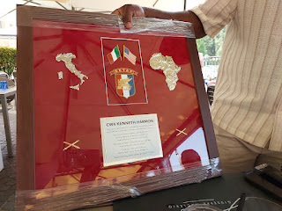

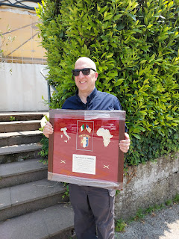

One more surprise took place before the lunch group dispersed, and that was to present Lt. Colonel "O" with a large framed plaque of his own, since he'll be moving to Korea very soon. Words of praise and appreciation were given, and then they read off to the group what it says on the plaque.

Since Lt. Colonel "O" is from Nigeria, the quote he says most often around the workplace - and what ended up on his plaque was this:

"There's no better example of mis/disinformation than presenting Ghanian jollof (aka jambalaya) as real jollof."

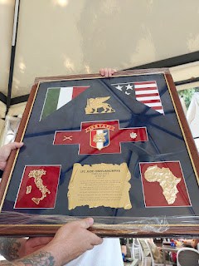

Below are many of Scott's buddies from work. I'll keep their names confidential to protect their privacy, but Scott's closest buddy is Jason Rico, seated in the front row - far left in the plaid shirt. They do some amazing teamwork when it comes to computer stuff - two genius brains and the nicest personalities, too. Jason is a contractor like Scott is now, too.

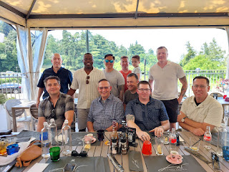

Happy 4th of July!! We will be hiking in the Swiss Alps this weekend to celebrate. Yodelayheehoo!!!